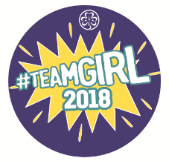
The Hong Kong Girl Guides Association
International Day of the Girl 2018
Cloth Badge Collection Form

After completing the required activities in the “International Day of the Girl 2018” (IDG 2018) Activity Pack, Appointed Guiders have to complete this form and submit to the Programme Department for cloth badge collection. The office would try to arrange the badges for collection on the designated date as provided by the Guider. Badges would only be given to members who have completed the IDG 2018 Challenges and each of them could receive one free badge only.

Name of Guider: Division: ____________ District:
Unit Number: __________________________ Brownie Guide Ranger
Contact Number: _______________________ Email: ____________________________
No. of badge requested: ___________ (one badge for each girl)
Signature of Guider: ________________ Expected collection date: ________________

Members who have completed IDG 2018 Programme
 | Name |  | Name
 |  | 16.
 |  | 17.
 |  | 18.
 |  | 19.
 |  | 20.
 |  | 21.
 |  | 22.
 |  | 23.
 |  | 24.
 |  | 25.
 |  | 26.
 |  | 27.
 |  | 28.
 |  | 29.
 |  | 30.

Please submit the form via post, fax, e-mail or in person
(Address: 8 Gascoigne Road, Kowloon, Hong Kong Fax: 2782 6466 Email: tpg@hkgga.org.hk)
Collection Time: Monday to Friday, 9:00a.m. to 5:30p.m. (Except Public Holidays)

