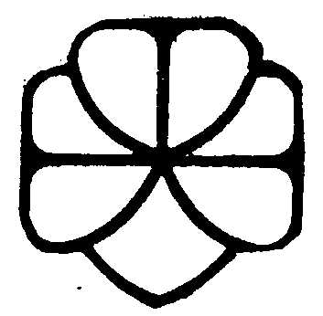
Deadline：
8th September 2025
before 5:00pm
The Hong Kong Girl Guides Association
The Outstanding Unit Award Scheme 2024–2025
Appeal Form

According to the information on the website, (Unit Number) was not selected as one of the awarded units, and we would like to submit an appeal against the result. Please return the copy of our record form in order to review the reasons for the failure in the Outstanding Unit Award. The contact information of our unit is as below,
Name of Guider-in-charge:
Contact Telephone Number:
E-mail:

Guider Signature: Date:
c.c.: Corresponding district commissioner and division representative

Remarks: Appeal period is restricted to 5 working days after the release of result on the website. Please send the appeal form to the corresponding RDD staff via fax (2782 7979) e-mail: oggu@hkgga.org.hk or mail on or before 8th September 2025 (5:00 pm). Late application will not be accepted.

